Lesson Plan: Building Habitat for Pollinators
Title: Building Habitat for Pollinators
Grade Levels: PreK–Grade 6 (adaptable)
Duration: 45–60 minutes
Location: Outdoor planting space or schoolyard

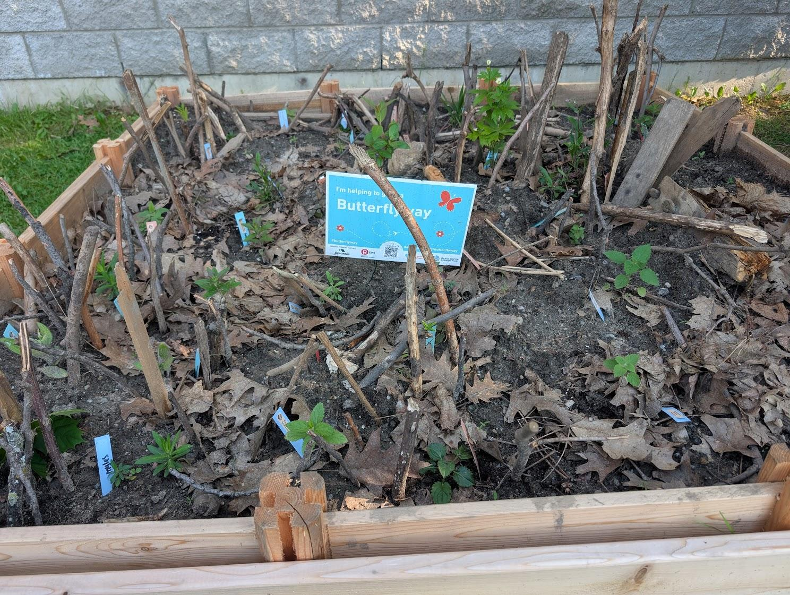

Learning Objectives
By the end of this lesson, students will be able to:
- Explain what pollinators are and why they are important
- Understand the concept of pollination through demonstration
- Identify several native pollinators, including specialist species
- Understand the needs of pollinators: food, water, shelter
- Participate in creating pollinator habitat by planting native species
- Demonstrate teamwork and environmental stewardship

Materials Needed
- Yellow pompons (representing pollen)
- Double-sided tape dots (to hold pompons, placed on shoulder)
- Butterfly wings (for student volunteer)
- Printed photos or slideshow of:
  - Honeybee
  - Bumblebee
  - Sweat bee
  - Leafcutter bee
  - Pearly banded bee
  - Monarch butterfly
  - Moth
  - Hummingbird
  - Fruit-eating bird
  - Bat
  - Wind-blown seeds (e.g., dandelion)
  - Rusty Patched Bumblebee
  - Example nesting sites for solitary bees (hollow stem, under leaves, etc.)
- Hollow plant stems or drilled wood (bumblebee nesting example)
- Shovels, trowels, forks/spoons (for digging)
- Watering can or jugs
- Native pollinator-friendly plants and grasses / sedges (seedling or plug size is fine. Aim for spring / fall blooms to align with school calendar)
- Natural materials from school yard (ideally children gather)
- Popsicle sticks (marking planting spots)
- Sign for Butterflyway (if available)

Lesson Structure

1. Introduction (5–10 minutes)
Engagement Hook:
Introduce yourself as a Butterfly Ranger. Invite students to help butterflies and their friends by learning about them and planting a special garden.

2. Circle of Life Game (5–10 minutes)
- Ask students what nature is and what’s alive in it.
- Form a circle and hold hands to show interconnection.
- Explain extinction as breaking the circle (e.g., dinosaurs).
- Discuss how animals rely on plants, and plants come from seeds, which come from pollinated flowers.

3. Pollination Demonstration (10–15 minutes)
- Use photos to show flower and bee covered in pollen.
- Explain pollen transfer using yellow pompons and tape.
- Select a volunteer pollinator (give butterfly wings).
- “Pollinate” another flower (teacher/student) with a high-five.
- Reinforce how pollination = making seeds and baby plants.
Adaptations:
- PreK–K: Emphasize movement, sounds ("buzz like a bee"), fewer facts.
- Grades 1–3: Include more examples of plants we eat.
- Grades 4–6: Introduce the role of nectar, and native vs. non-native bees.

4. Pollinator Picture Quiz (5–10 minutes)
Show each photo and ask students to guess what it is and what makes it special. Include:
- Specialist pollinators (e.g., Monarch and Milkweed)
- Nocturnal pollinators (moth, bat)
- Surprise pollinators (birds, wind)
- Highlight Rusty Patched Bumblebee (endangered) and ask why it might be missing (food/shelter loss)
Adaptations:
- PreK–K: Focus on colors and features (e.g., "fuzzy bee!" "blue bee!").
- Grades 1–3: Emphasize who eats what and when (day vs night).
- Grades 4–6: Discuss habitat loss, native plant importance, and food webs.

5. Nesting Needs & Habitat Discussion (5 minutes)
- Pass around sticks with holes: “Where do bumblebees live?”
- Discuss difference between honeybee hives and wild bees.
- Prompt kids to look around: where are good hiding spots for pollinators? Is pavement/roof/grass helpful?

6. Habitat Creation Activity (20–30 minutes)
Split Class in Two:
- Group A: Planting
  - Demonstrate digging, removing plant from pot, planting, patting soil, watering.
  - Introduce the plant (name and who it helps, if known).
- Group B: Habitat building
  - Collect natural materials (sticks, leaves, stems) for shelter/mulch.
Switch groups halfway through.
Adaptations:
- PreK–K: Let them explore textures and shapes. Sort and separate natural materials. Adult-assisted planting.
- Grades 1–3: Talk more about roots, names of plants.
- Grades 4–6: Involve them in deeper plant selection reasoning (shade, sun, spacing).

7. Wrap-Up & Reflection (5 minutes)
- Recap: What did we learn about pollinators?
- Show the Butterflyway sign.
- Celebrate: “We just built a stop on a Butterflyway!”
- Invite them to help pollinators at home too.
- Optional: Take a group photo to commemorate.

Assessment Ideas
- Ask students to name one pollinator and one thing they learned.
- Have older students draw a pollinator and label its role.
- Create a “Thank You Pollinators” poster as a follow-up.

Extensions & Optional Activities
- Art: Decorate large Butterflyway sign collectively as a class.
- Writing: Create information posters for each planted species, or targeted pollinator species
- Science: Observe garden weekly and record pollinator visits. Research pollinator value of each plant planted, along with specialist and generalist pollinator relationships (i.e. milkweed and monarch butterfly)
- Home Connection: Encourage students to build bee hotels or plant native seeds.

